

**COMSATS University Islamabad**

**Wah Campus**

Department of Computer Science(SE)**:**

***Submitted To:***

***Dr. Wasif Nisar***

***Submitted By:***

|  |  |
| --- | --- |
| ***Name***  ***Muhammad Saad*** | ***Reg. No***  ***SP21-BSE-069*** |

Table of Contents

# **1.** **Introduction .............................................................................................................. 4**

1.1 System Introduction ...................................................................................................... 4

1.2 Background of the System ............................................................................................. 4

1.3 Objectives of the System ............................................................................................... 4

1.4 Significance of the System ............................................................................................ 4

* Retail Bookstores: .................................................................................................. 4
* Educational Institutions: ......................................................................................... 4

# **2.** **Overall Description .................................................................................................... 5**

2.1 Product Perspective ...................................................................................................... 5

2.2 Product Scope .............................................................................................................. 6

2.3 Product Functionality .................................................................................................... 6

2.3.1 Admin Perspective .................................................................................................. 6

2.3.2 Customer Perspective ............................................................................................ 6

2.4 User and Characteristics ............................................................................................... 6

2.4.1 Admin Perspective: ................................................................................................. 6

2.4.2 Customer Perspective: ........................................................................................... 6

2.4.3 Most Important Users: ............................................................................................ 7

2.5 Operating Environment ................................................................................................. 7

2.5.1 Hardware Platform: ................................................................................................ 7

2.5.2 Operating System: .................................................................................................. 7

# **3.** **Specific Requirements................................................................................................ 8**

3.1 Functional Requirements .............................................................................................. 8

3.1.1 Book Management ................................................................................................. 8

3.1.2 Sales Tracking ........................................................................................................ 8

3.1.3 Customer Management .......................................................................................... 8

3.1.4 Reporting ............................................................................................................... 8

3.1.5 Book Search Functionality ...................................................................................... 9

3.1.6 Customer Feedback ............................................................................................... 9

3.2 Behaviour Requirements ............................................................................................... 9

3.2.1 Admin: ................................................................................................................... 9

3.2.2 Customer: .............................................................................................................. 9

3.3 External User Interface ................................................................................................ 10

3.3.1 User Interface: ...................................................................................................... 10

# **4.** **Non-Functional Requirements.................................................................................. 12**

4.1 Performance Requirements ......................................................................................... 12

4.2 Safety and Security Requirements ............................................................................... 12

4.2.1 Data Integrity: ....................................................................................................... 12

4.2.2 Error Handling ...................................................................................................... 12

4.2.3 User Authentication: ............................................................................................. 12

4.2.4 Data Encryption: ................................................................................................... 12

4.3 Software Quality Attributes.......................................................................................... 12

4.3.1 Reliability ............................................................................................................. 12

4.3.2 Availability ............................................................................................................ 12

4.3.3 Useability ............................................................................................................. 12

4.3.4 Flexibility .............................................................................................................. 12

4.3.4 Portability ............................................................................................................. 13

4.3.5 Security ................................................................................................................ 13

4.3.6 Correctness ......................................................................................................... 13

4.3.7 Adaptability .......................................................................................................... 13

# **5.** **Design Description ................................................................................................... 14**

5.1 Logical Viewpoint ........................................................................................................ 14

5.2 Information Viewpoint ................................................................................................. 15

5.3 Interaction Viewpoint: ................................................................................................. 16

5.4 State Dynamics Viewpoint ........................................................................................... 19

5.5 Algorithm Viewpoint .................................................................................................... 19

1. Introduction

# 1.1 System Introduction

The Bookstore Management System is designed to help bookstore owners manage their daily tasks efficiently. This software allows users to easily add, update, and remove book records, track sales, and manage customer information.

Its main purpose is to keep the bookstore's inventory accurate, monitor sales performance, and generate helpful reports. The system also provides a user-friendly interface and simple search features to ensure a smooth and productive experience for all users.

This system will also provide feedback mechanism for customers and with additional functionality search book for them.

# 1.2 Background of the System

Existing bookstore management systems like Lightspeed Retail and Square for Retail help manage inventory, sales, and customers but often have complex interfaces and high costs. Our Bookstore Management System aims to be simpler, more user-friendly, and affordable, making it easier for anyone to use while offering better customization and reporting features.

# 1.3 Objectives of the System

* Simplify the process of adding, updating, and removing book records.
* Track sales accurately and efficiently.
* Manage customer records with ease.
* Generate various reports, including sales and inventory reports.
* Provide a user-friendly and intuitive interface.
* Facilitate easy search and retrieval of book information.
* Enable customers to submit feedback and allow users to manage it effectively.

# 1.4 Significance of the System

The Bookstore Management System is important because it streamlines bookstore operations, saving time and reducing errors. It can be used in various application areas, including:

* Retail Bookstores: Enhances inventory management, sales tracking, and customer service.
* Educational Institutions: Supports bookstores in schools and universities by organizing and tracking textbooks and other educational materials.

2. Overall Description

# 2.1 Product Perspective

The Bookstore Management System is a new, standalone product designed to simplify bookstore operations. Unlike broader retail systems, it focuses specifically on bookstore needs, offering detailed book inventory management, sales tracking, and customer service features. This system replaces manual processes with an integrated digital solution for better efficiency and accuracy.

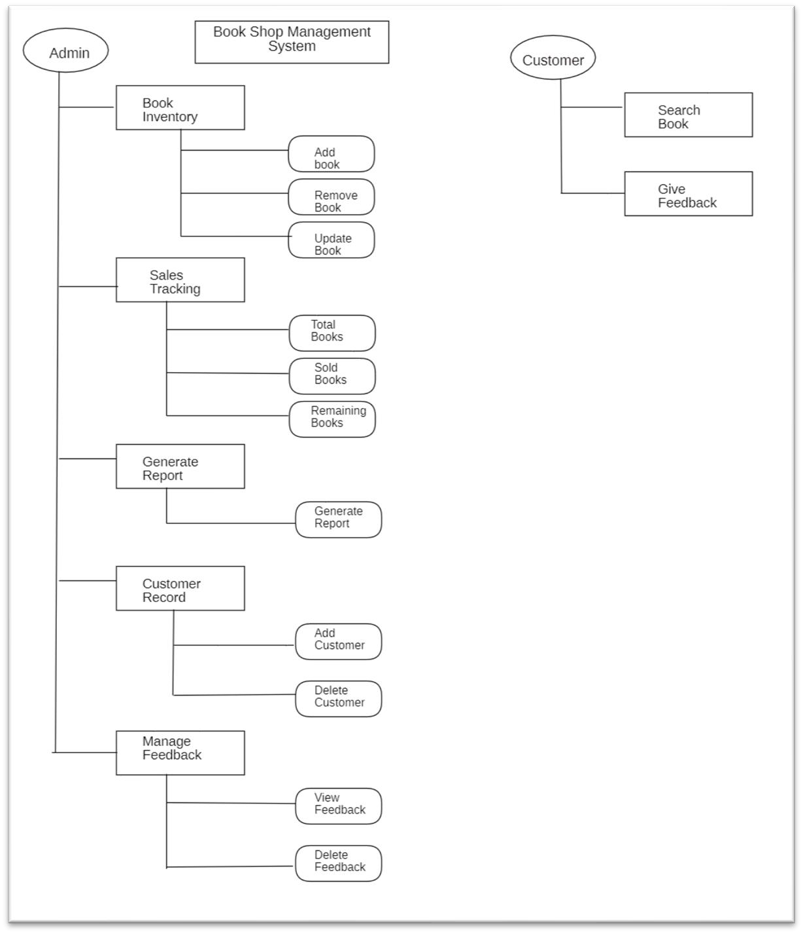

**General Diagram for the System fig1.1**

# 2.2 Product Scope

The Bookstore Management System will manage book inventory, track sales, maintain customer records, generate reports, and collect customer feedback. It will have an easy-touse interface for staff and administrators to add, update, and remove books, record sales, manage customer information and manage feedback by the customer.

The system will not include features like online payment processing, integration with external shipping services, or handling non-book retail products. It is focused solely on the needs of physical and online bookstores. 2.3 Product Functionality

## 2.3.1 Admin Perspective

* Book Inventory Management
* Sales Tracking
* Customer Management
* Reporting
* Search Book
* Manage Customer Feedback

## 2.3.2 Customer Perspective

* Give Feedback
* Search Book

# 2.4 User and Characteristics

2.4.1 Admin Perspective:

1. **Owner of Book Shop/Manager**

* Moderate frequency of use
* High technical expertise
* Oversee daily operations and user management
* High importance 2.4.2 Customer Perspective:

1. **Customers**

* Occasional users
* Low technical skills
* Use for searching books and giving feedback
* Medium importance

2.4.3 Most Important Users:

* **Store Administrators:** Ensuring smooth system functionality and control.
* **Customers:** Vital for business success, as their satisfaction drives sales and loyalty.

# 2.5 Operating Environment

The Bookstore Management System is designed to operate in a typical retail environment, utilizing standard hardware and software components. The minimum platform requirements for the system are as follows:

2.5.1 Hardware Platform:

* Desktop or laptop computer
* Minimum 4GB RAM
* Intel Core i3 processor or equivalent 2.5.2 Operating System:
* Windows 10 or later
* macOS 10.12
* Linux

3. Specific Requirements

# 3.1 Functional Requirements

## 3.1.1 Book Management

* **Add Book Records:**
* Users should be able to enter book details such as title, author, ISBN, genre, price, and quantity into the system.
* **Update Book Records:**
* Users should have the ability to edit existing book information, including modifying details like price, quantity, or genre.
* **Remove Book Records:**
* Users should be able to delete book records from the system, removing books that are no longer available for sale.

## 3.1.2 Sales Tracking

* **Record Sales Transactions:**
* The system should allow users to record sales transactions, including the date, books sold, quantity, and total amount.
* **Update Inventory:**
* Upon completing a sale, the system should automatically adjust the book inventory to reflect the items sold and other will be see total stock and sold stock.

## 3.1.3 Customer Management

* **Add Customer Records:**
* Users should be able to input new customer information, including name, contact details, and purchase history.
* **Update Customer Records:**
* Users should have the ability to edit existing customer information, such as updating contact details or adding notes.
* **Remove Customer Records:**
* Users should be able to delete customer records from the system, removing outdated or irrelevant information.

## 3.1.4 Reporting

* **Generate Sales Reports:**
* The system should provide functionality to generate reports summarizing sales over a specified period.

## 3.1.5 Book Search Functionality

* **Search by Keywords:**
* Users should be able to search for books using keywords such as title, author, ISBN.
* Search option will also be available for customer on respective different system.

## 3.1.6 Customer Feedback

* **Feedback Submission:**
* Customers should have the ability to submit feedback about books or their shopping experience through the system.
* **Feedback Management:**
* Users should be able to view, respond to, and manage customer feedback within the system, ensuring prompt and effective communication with customers.

# 3.2 Behaviour Requirements

Two types of actors that will interact with a system in different manner.

3.2.1 Admin:

Admins**(Actor)** have association to following use cases:

* Add Book
* Update Book
* Remove Book
* Search Book
* Sales Track
* Generate Report
* Customer Record
* Feedback Management

3.2.2 Customer:

Customer (Actor) have association with following use cases:

* Search Book
* Give Feedback

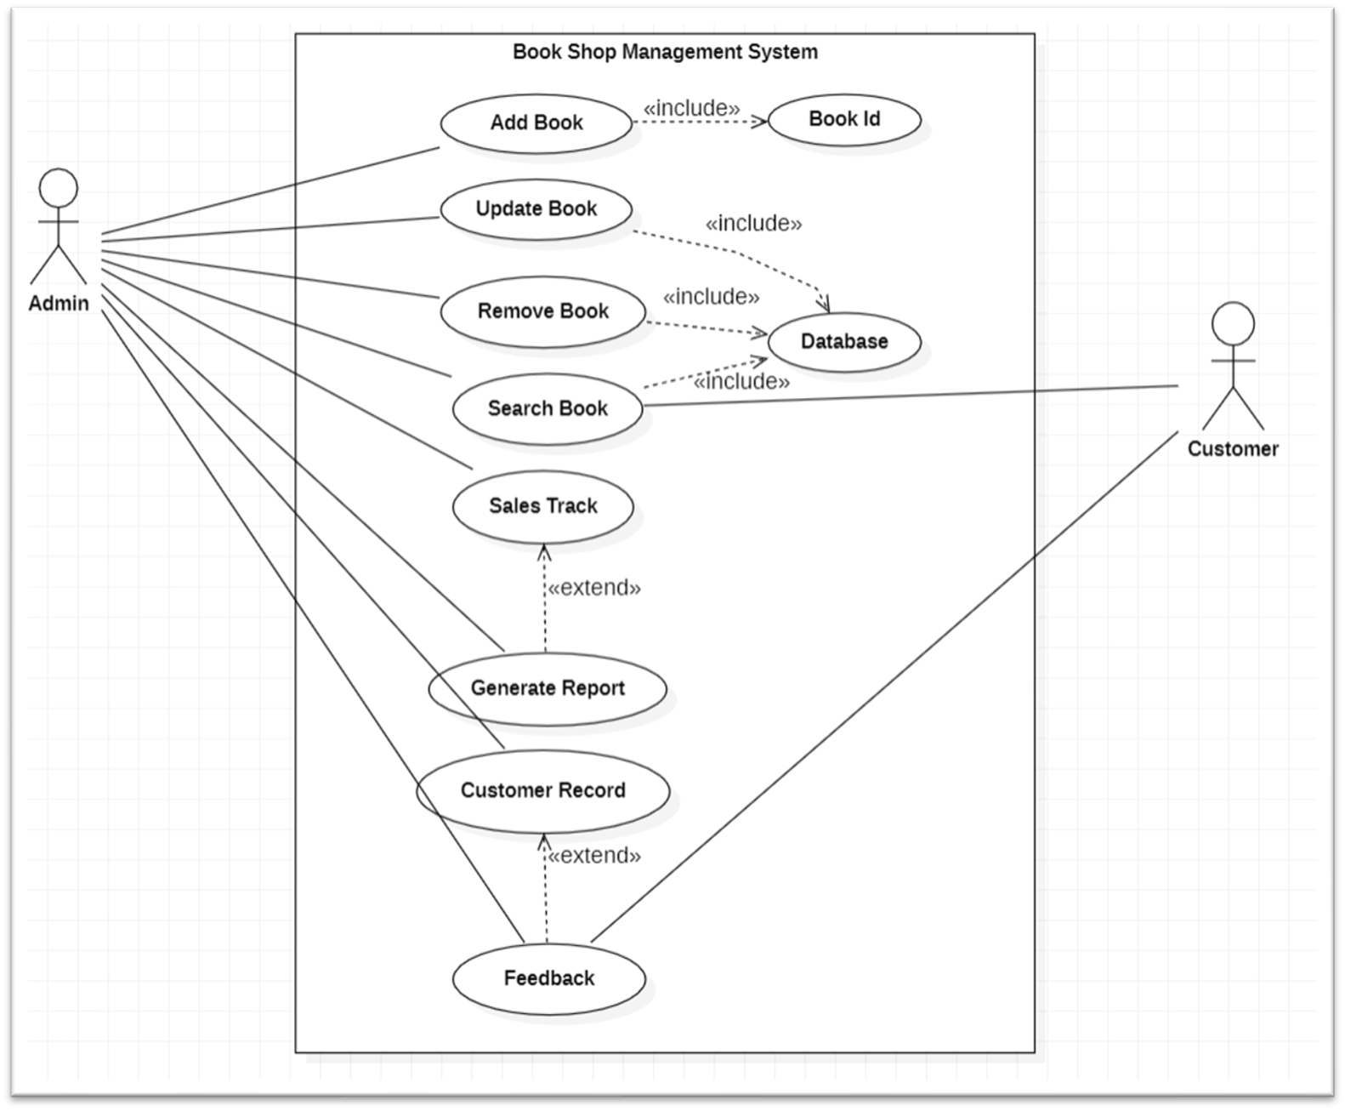

**Use Case Diagram of the System fig1.2**

# 3.3 External User Interface

3.3.1 User Interface:

1. **Login Screen:** Admin enter their username and password to access the system.
2. **Dashboard:** Upon login, users see a summary of key metrics and shortcuts to important features mentioned below.
3. **Book Management:** Users add, update, or remove book records, entering details like title, author, and quantity.
4. **Sales Tracking:** Sales transactions, specifying books sold and total amount.
5. **Customer Management:** Users manage customer records, adding new customers or updating existing information.
6. **Reporting:** Admin can generate sales reports.
7. **Search and Browse:** Customers search for books by title, author, or genre, or browse through categories.
8. **Feedback Submission:** Customers provide feedback on books or shopping experience, submitting comments or ratings.

After login with correct credentials, user will have access to dashboards where all the key functionalities will appear, and user can perform task of his own choice and at the end log out button will be provided at the bottom left corner where system will exit at the end.

All these things will be provided in drop down menu.

4. Non-Functional Requirements

# 4.1 Performance Requirements

* After entering username and password system will show dashboard immediately.
* Adding, updating, or removing book records must be completed within 5 seconds.
* Recording a sale should not take more than 3 seconds.
* Book search results must be displayed within 2 seconds.
* Generating sales reports of data should be completed within 10 seconds.
* Adding or updating customer records should not exceed 3 seconds.
* In-case of any error system will display error message immediately.
* After Pressing save button system will show data saved successfully.

# 4.2 Safety and Security Requirements

4.2.1 Data Integrity:

The system must ensure that all data entries are accurate and consistent.

## 4.2.2 Error Handling

The system must provide clear error messages and log all errors.

4.2.3 User Authentication:

All users must authenticate using a username and password.

4.2.4 Data Encryption:

All sensitive data must be encrypted like login credentials.

# 4.3 Software Quality Attributes

4.3.1 Reliability

* The system must have an uptime of 99.9% during business hours.

4.3.2 Availability

* The system must be available 24/7.

4.3.3 Useability

* Users should be able to perform any task at any time.

## 4.3.4 Flexibility

• The system must support the addition of new features without significant changes to the existing codebase.

## 4.3.4 Portability

* The system should be able to run on various operating systems and devices without modification.

4.3.5 Security

* The system must protect against unauthorized access and data breaches.

4.3.6 Correctness

* The system must accurately perform all specified functions without errors.

4.3.7 Adaptability

The system must easily adapt to changes in user requirements and operating environments.

# 5. Design Description

5.1 Logical Viewpoint

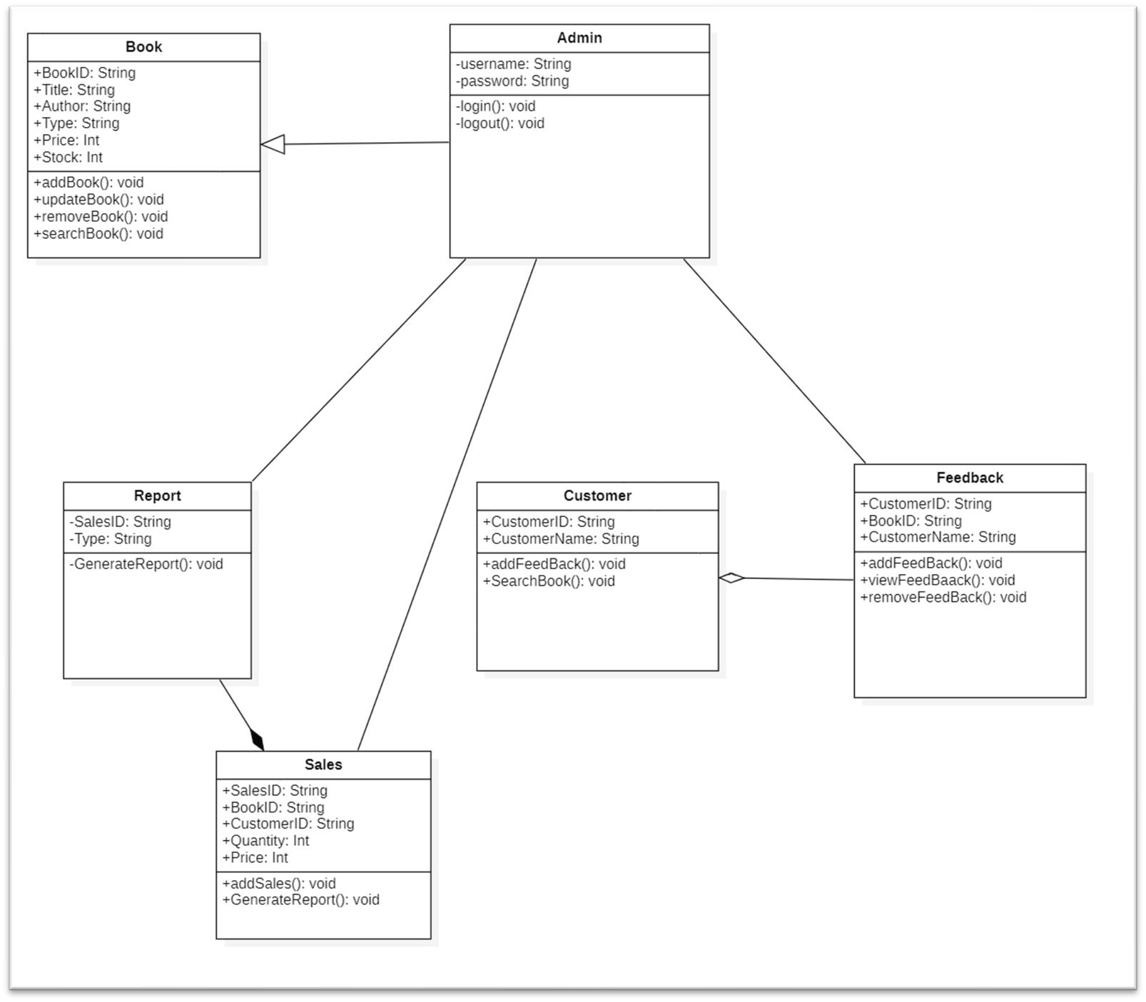

**Class Diagram of the System fig 1.3**

## 5.2 Information Viewpoint

**ER Diagram of the System fig1.4**

5.3 Interaction Viewpoint:

Following are diagram for the use-cases mentioned above in use-case diagram fig1.2:

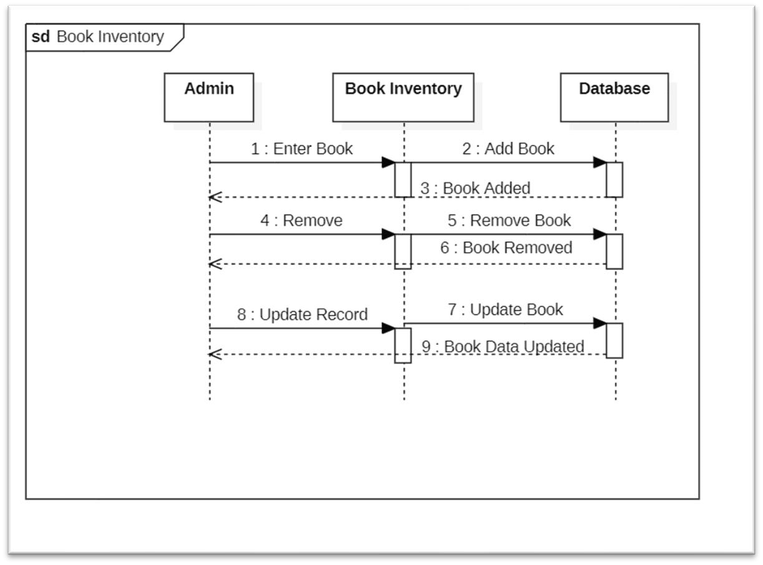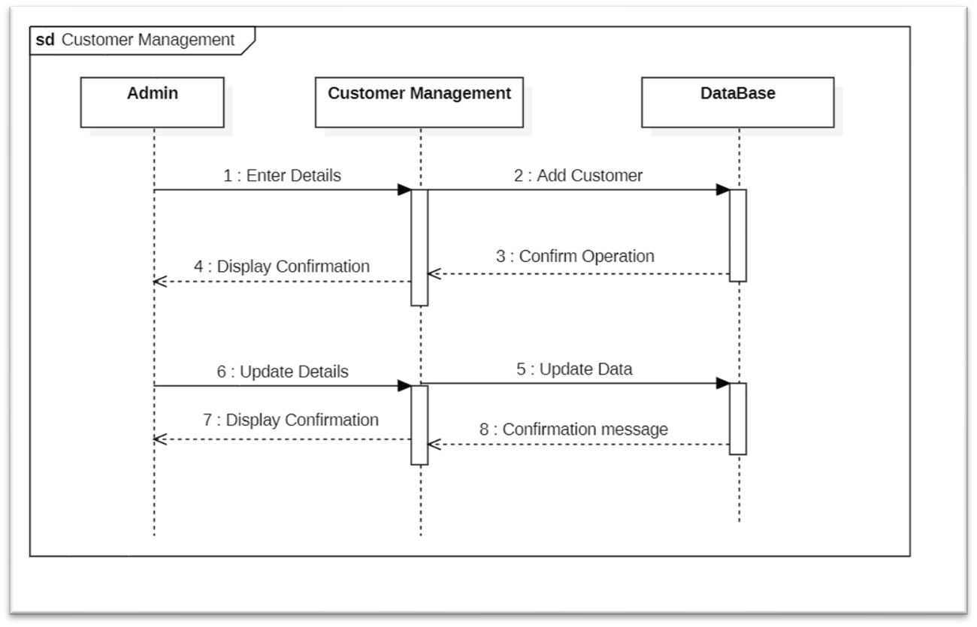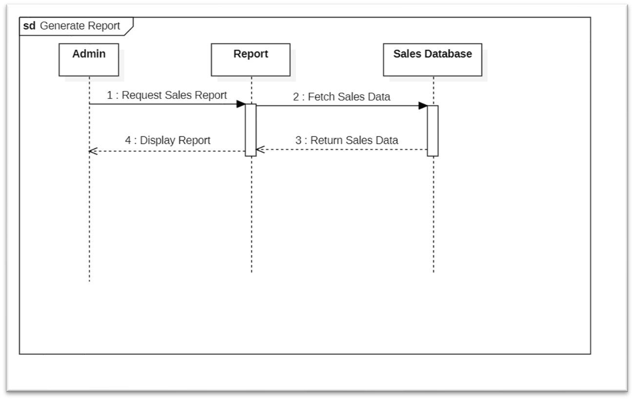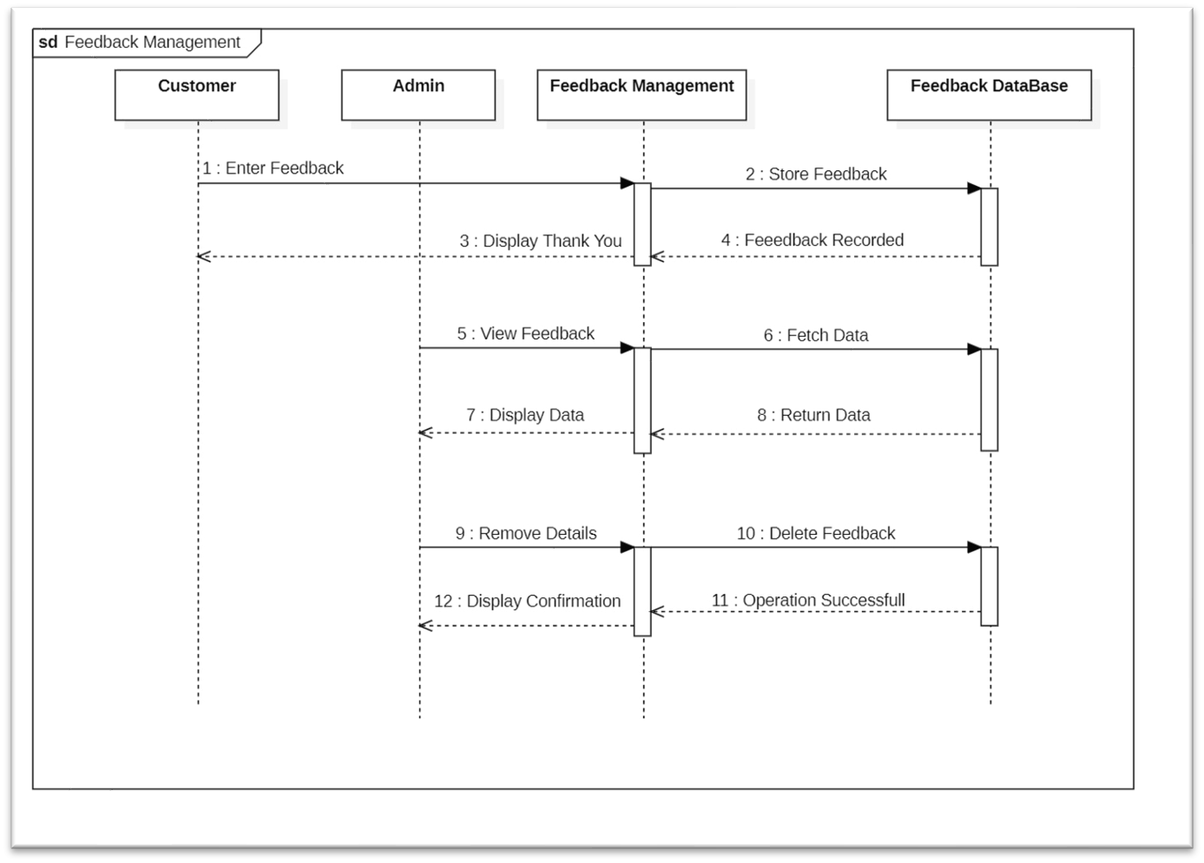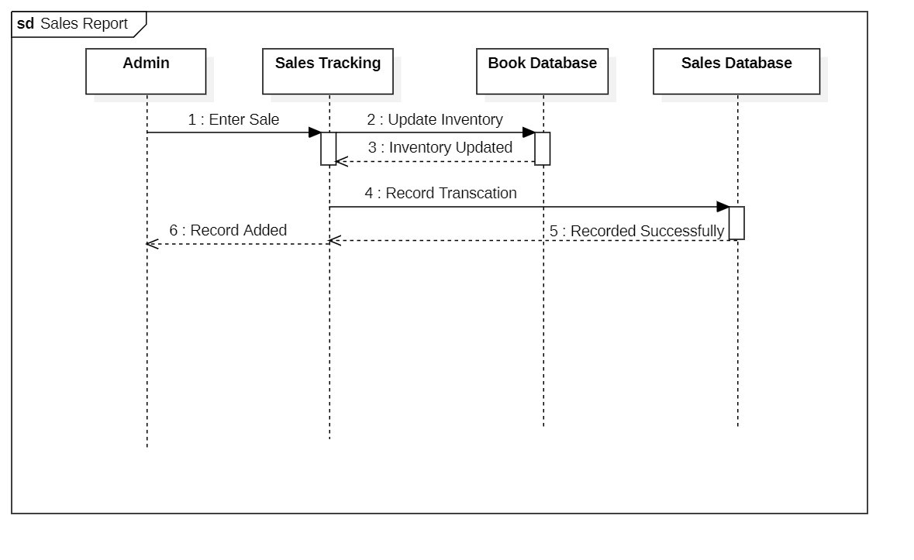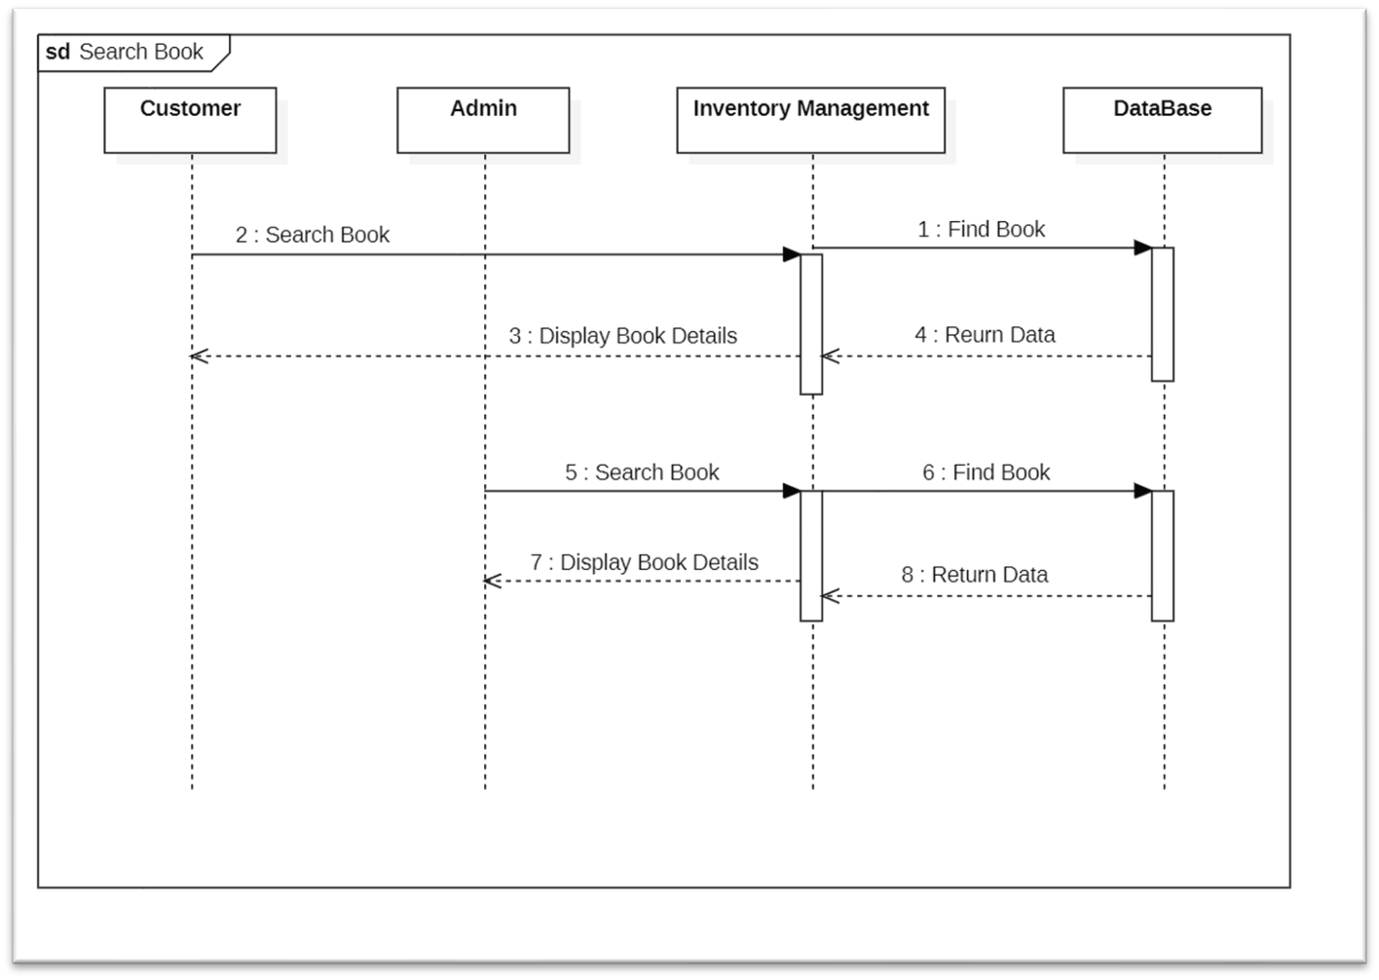

**Sequence Diagram with respect to use cases of the system**

## 5.4 State Dynamics Viewpoint

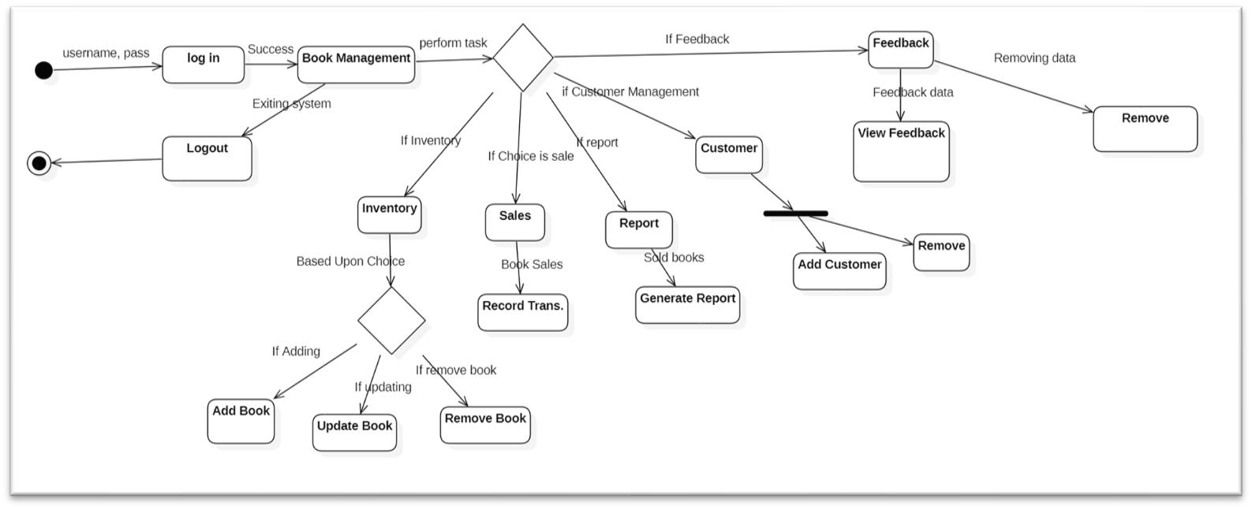**State Machine Diagram of the system** 5.5 Algorithm Viewpoint

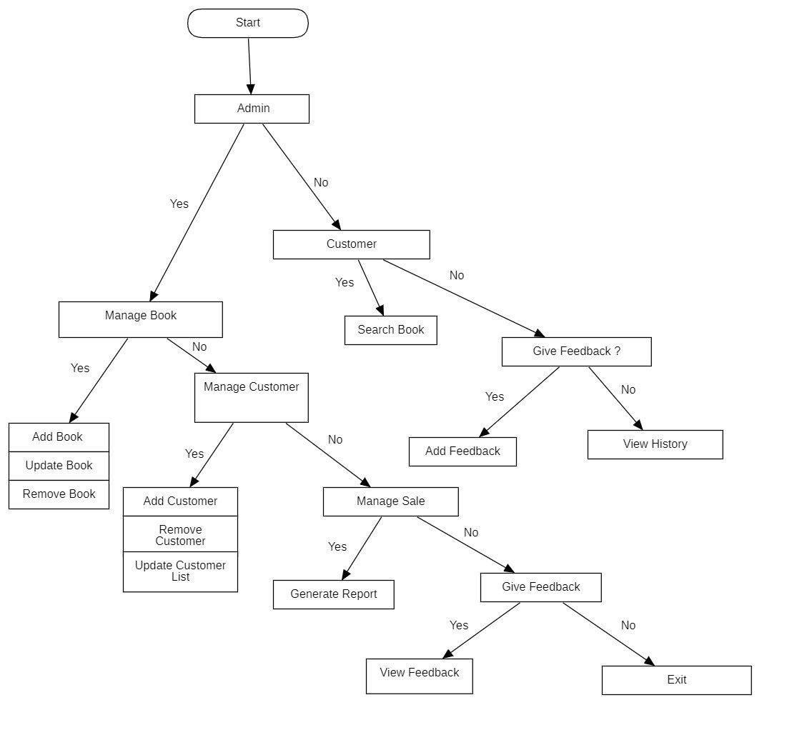

**Decision Tree Diagram of the system**